Refresh, Revamp, Succeed!
AUB Grad Webinar Series for Launching Your Career
Own Your Creativity: Breaking into Industry with Confidence
Tuesday 1st APRIL 1.00-2.00pm

Stepping into your first role can feel daunting, but confidence is key to making your mark. In this session, you'll explore practical ways to identify your unique strengths and effectively communicate them—whether you're applying for jobs, networking, or pitching to clients. You'll leave feeling positive, motivated and raring to go with the tools to showcase your talent and take bold steps toward your creative career.
Book Here
Teams link to join
_________________________________________
Crafting Your Career: How to Tailor Your CV for Any Role
Thursday 3rd April 1.00-2.00pm

Your CV isn’t one-size-fits-all—it's a creative tool that should evolve with each
opportunity. In this webinar, you'll learn how to adapt your CV to highlight the right skills and experiences for different roles, making you stand out to employers and clients. Whether you're applying for jobs, freelance gigs, or creative opportunities, this session will give you the confidence to present yourself in the best possible light.
Book here
Teams link to join
Building your Professional Network: The Creative Collective, Sharing, supporting and succeeding!
Tuesday 8th April 5.00-6.00pm
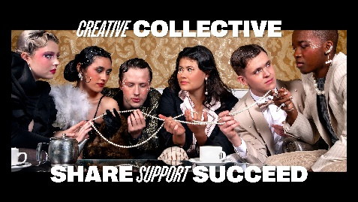
Networking isn’t just about making contacts—it’s about building meaningful connections that can shape your career. In this interactive session, we’ll break down a simple networking framework, bust common myths, and explore how to find your creative community. You'll also get the chance to put your skills into practice and share insights with fellow graduates. Whether you're freelancing, job searching, or looking for collaborators, this session will help you grow your network with confidence and authenticity.
Book Here
Teams Link
_________________________________________
Job Hunting for Creatives: Strategy, Skills, and Success
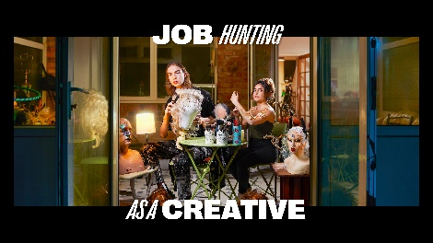
Thursday 10th 1.00-2.00pm
Job hunting in the creative industries goes beyond the usual job boards and recruiters. In this session, we’ll dive into strategies for uncovering the hidden job market, including speculative applications and exploring often overlooked creative job hunting platforms. Learn how to conduct targeted research to find opportunities that aren’t advertised, and discover how to stand out when reaching out to potential employers. Whether you're looking for freelance gigs, full-time roles, or collaborations, this session will equip you with the essential skills and mindset to navigate the creative job market with confidence and success.
Book Here
Teams Link

