MENTORING SCHEME: MY OBJECTIVES
Use this document to think about the key skills and knowledge you would like to improve on during this mentoring scheme.
You will meet with your mentor 4-6 times so it’s a good idea to think about the different topics you would like to discuss so that you can make the most of the time you have together.
You are in the driving seat! While you mentor will help you to think about how you can achieve your goals, it’s a good idea to have some ideas of what your goals are before you start!
Don’t worry, they won’t expect you to know everything at all! They will be on hand to guide and discuss your ideas with you and offer their perspective, but it can be helpful to do a bit of prep!
Some ideas to get started:
- Before your first meeting with your mentor, log onto AUB Futures here: https://aub.targetconnect.net/
- Look for the “Skills” and complete the quiz – use this to help you reflect on the skills you need to develop.
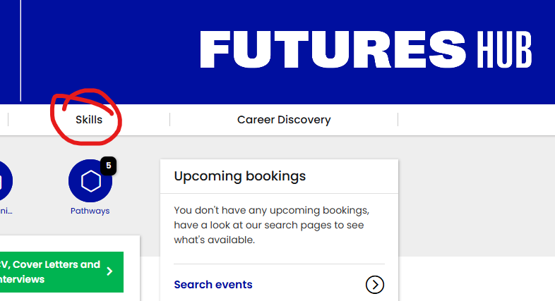
- Do a little research into the area of industry you are interested in you could have a look at Futures Hub and sites like Creative Lives in Progress, Discover Creative Careers and Prospects to get started. This will help fuel more questions for you to ask- nothing like hearing it from someone with lived experience!
Try to come up with a few areas that you would like to discuss with your mentor below. Make a list. From these areas you can agree to set yourself some goals together with your mentor so have a bit of a think before you arrive at your first meeting. Again, you don’t need to have all the answers, just a few thoughts to get started!
1.
2.
3.
4.
5.
6

