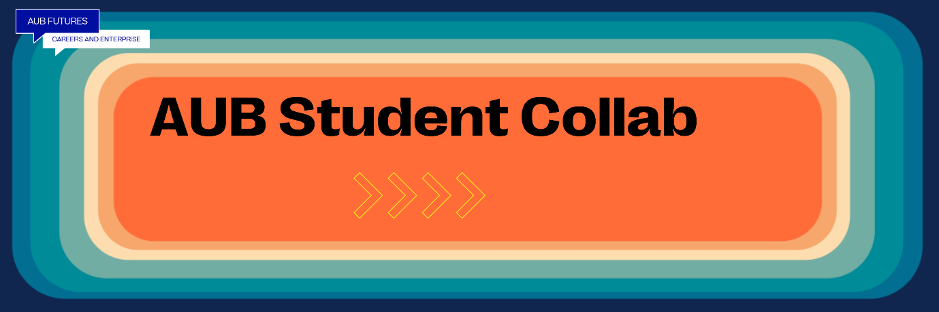
AUB Student Collab
Is a safe space to come along and meet students interesting in finding colleagues and friends from across the university for future collaborations
AUB Student Collab will meet on a monthly basis in the Innovation Studio. For information about upcoming dates and events go to AUB Bookings
There is also has a digital space where you reach out to find students from across the university to collaborate with on Canva.The AUB Student Collab Board!

Advertise on AUB Student Collab Opportunities Board
If you would like to advertise that you are looking for a student with a particular interest or skill set you can post an announcement on Canvas Student Collab Opportunities Board by filling in this form here

AUB Student Collab Opportunities Board
To see current opportunities on click here

Any problems, please email futures@aub.ac.uk and we will get back in touch with you asap!

