AUB Innovation & Enterprise Awards 2022 -23
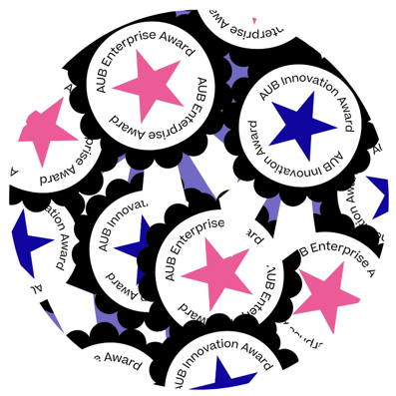
The Innovation and Enterprise Awards are a great opportunity to recognise students for their entrepreneurial activities or innovative ideas.
To be considered for the awards, courses must nominate students, so please encourage potential candidates to get involved.
Winners will receive £500 and their name will be included in the list of awards for graduation.

The Pitch
Those shortlisted will be put forward to pitch their ideas to a panel. They’ll get feedback on their ideas with signposting to further support for development.
AUB Innovation Award Nominating Criteria
Students nominated for the AUB Innovation award should have an idea or new business that demonstrates at least two or more of the following attributes:
- An idea that tackles a social aim
- A unique product or service that serves a market need
- An idea that has the potential for growth
- An idea that uses creative skills for innovation
- An idea that demonstrates the capabilities of creative technology
AUB Enterprise Award Nominating criteria
Students nominated for the AUB Enterprise Award should be outstanding in their entrepreneurial mindset. They may have an idea for a business or might have already started their own business. This could include a freelance service-based business.
The idea or business should demonstrate at least two or more of the following attributes:
- An idea that tackles a social aim
- A unique product or service that serves a market need
- An idea that has the potential for excellent growth
- A freelance or service-based creative business
- An artist, designer or maker with a commercial practise.

Application for both awards:
Those who are nominated and would like to participate in the awards must provide no more than two (2) sides of A4, including images demonstrating:
- Their concept and why it is innovative or why it is entrepreneurial
- How their idea addresses at least two of the criteria
- Their ambitions for the project
- Market research - Awareness of potential customers and competitors
- Evidence of relevant skills, experience, and motivation
Applications must be submitted to Alison Zorraquin, Employability Manager azorraquin@aub.ac.uk by midnight 29th May
Students will be shortlisted and will be required to prepare a 10-minute pitch about their idea or project which will be presented on 9th June preferably on campus in the Innovation Studio.
Time Scales
Action | date
Deadline for nominations | Monday 29th May
Pitch before panel to be held | Friday 9th June

