CV 1.

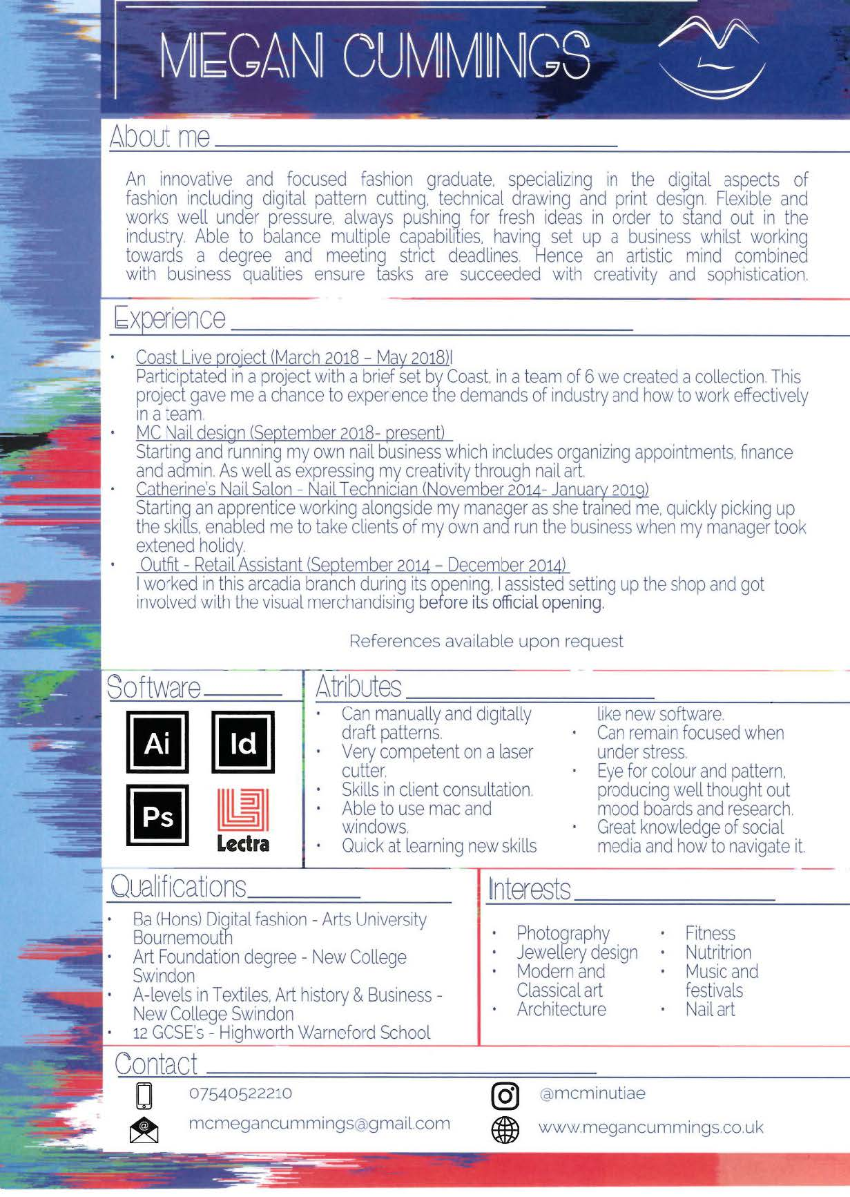

NAME

**Example 3**

CV 2.

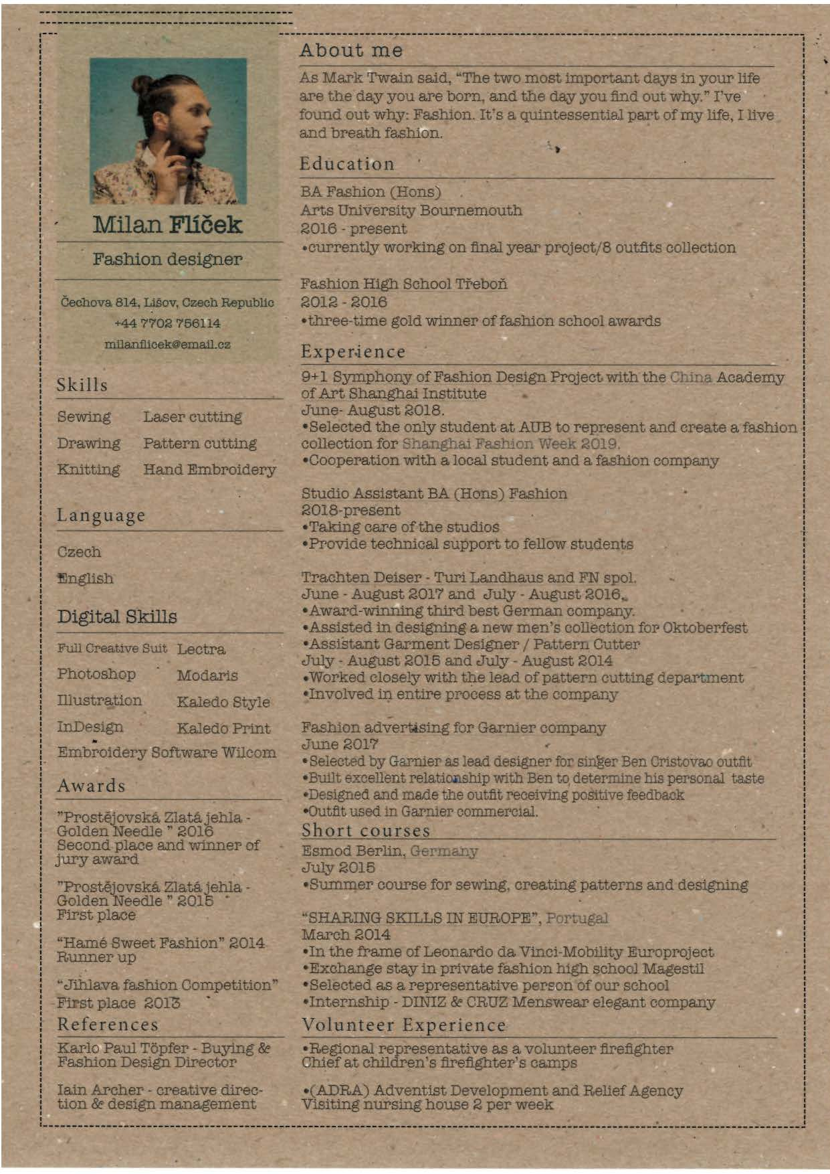

Address, Email, Number

Name and Photo

Contact details

**NAME**

**Personal details**

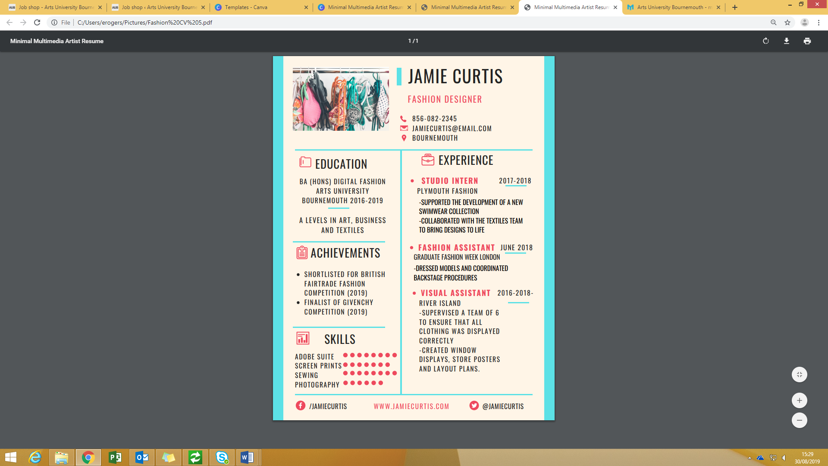**Example 3**

Name